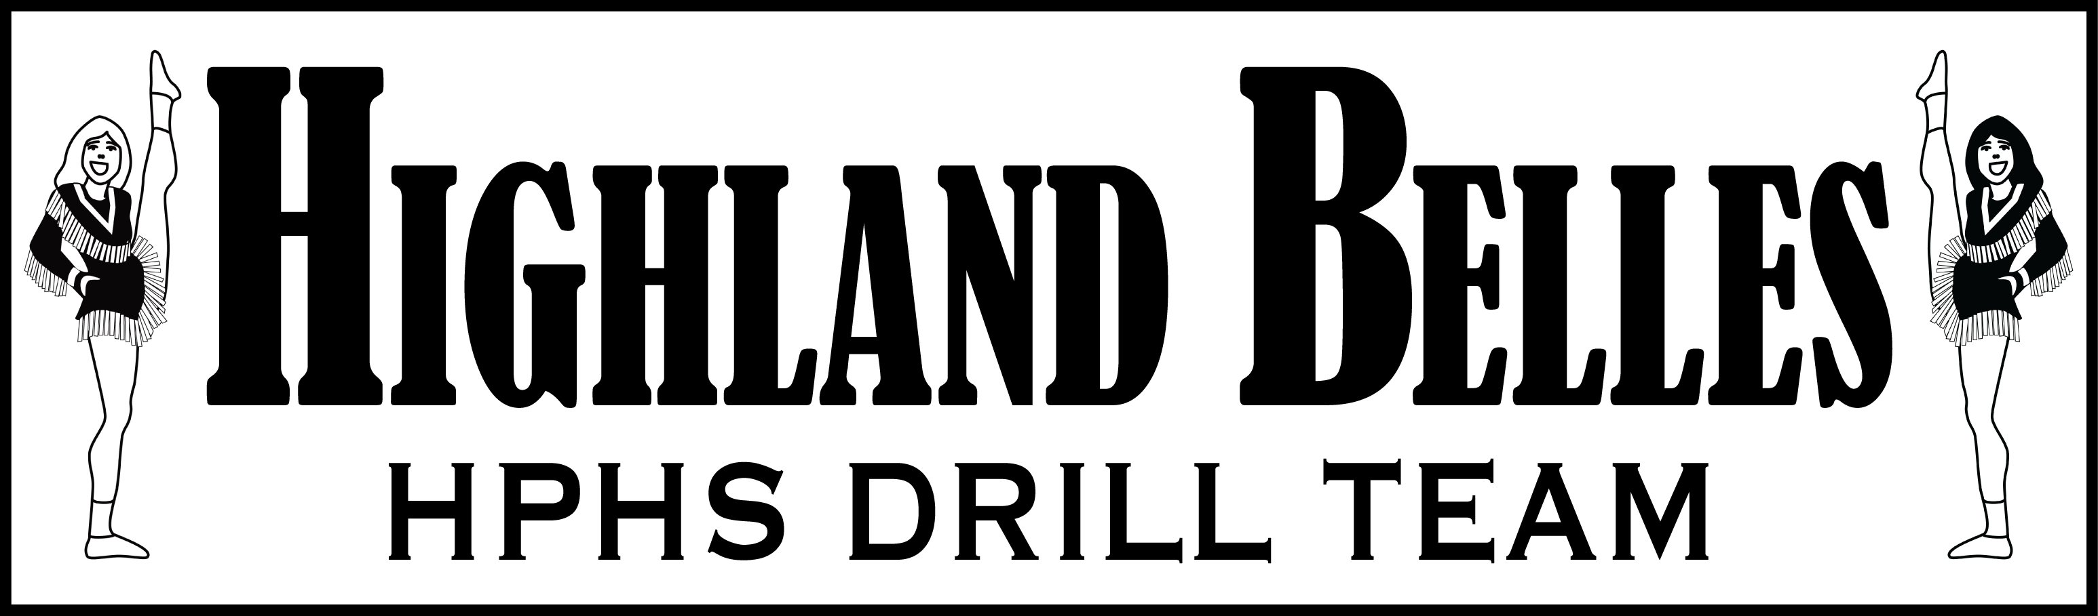

Highland Belles Salute Spaghetti Supper Sales Winners
The Highland Belles are proud to announce the annual Spaghetti Supper sales winners. All 63 members of the award-winning Highland Belles drill team sold dinner and raffle tickets and solicited underwriting donations.
All funds from the Highland Belles Spaghetti Supper and Auction help support the year-round operations of the drill team. The Belles would like to thank the community for its support of the annual Spaghetti Supper and Auction.
Shown left to right, Highland Belle Lauren Pettle finished first, Kate Kilpatrick second, and Meredith Sims third in sales of Spaghetti Supper and raffle tickets as part of the annual fundraiser.
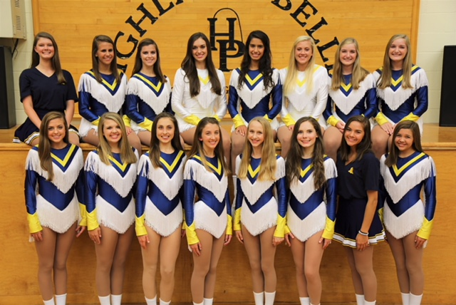
The three top-ranked tickets sales groups are defined by Gold, Silver and Blue Belles.
Gold Belles L to R: (front row) Arden Rasmussen, Ellie McFarland, Mary Frances McElroy, Lauren Pettle, Meredith Sims, Annabelle Ogden, Ella Ann Miller, Emerson Mason
(back row) Sophie Smythe, Carmen Sarfatis, Caroline Thomas, Brooke Marvel, Ava Jahant, Kate Kilpatrick, Barrett Groves, Margaret Groves
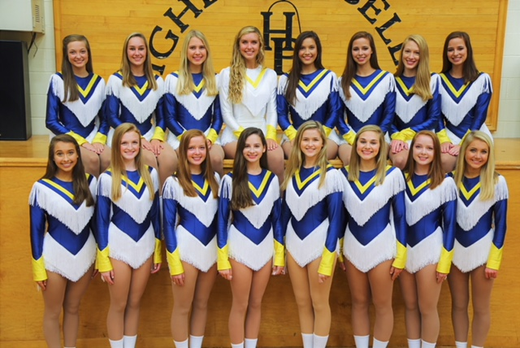
Silver Belles L to R: (front row) Daryn Rowlett, Bailey Eubanks, Audrey Stone, Hilary Hansford, Cierra Reed, Sophie Folts, Hannah Stone, Campbell Willis
(back row) Mary Margaret Ramey, Berkley Mason, Kennedi Feigl, Grace Dodd, Charlotte Glieber, Jamie Wander, Lauren Stevenson, Kristen Wander

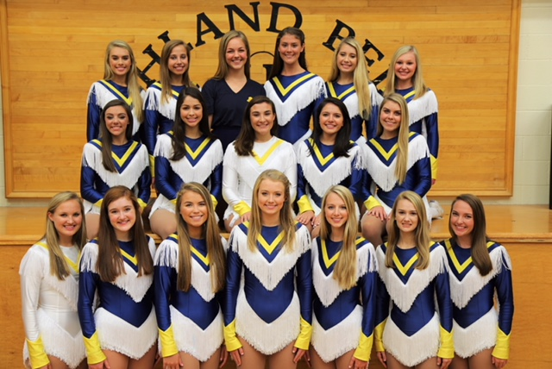
Blue Belles L to R: (front row) Talle Olsen, Sabrina Zevallos, Liv Brink, Casey Bowden, Sarah Fielder, Alexandra Whitlock, Avery Penman
(middle row) Olivia Jolas, Malena Maese, Riley Cheek, Lily Meneghetti, Mary Kate Addison
(back row) Olivia Pettijohn, Elisabeth Wiebe, Elizabeth Woodley, Margaret Kemp, Isabella Hughes, Oliva McFall
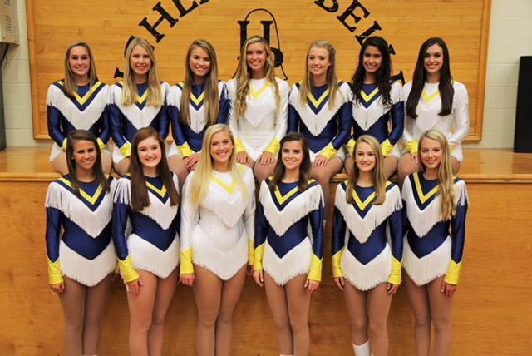
These Sensational Seniors raised more than $1,000 in each of their years as Highland Belles.
L to R: (front row) Carmen Sarfatis, Sabrina Zevallos, Kate Kilpatrick, Caroline Thomas, Alexandra Whitlock, Sarah Fielder
(back row) Berkley Mason, Kennedi Feigl, Liv Brink, Grace Dodd, Sarah Fielder, Ava Jahant, Brooke Marvel

