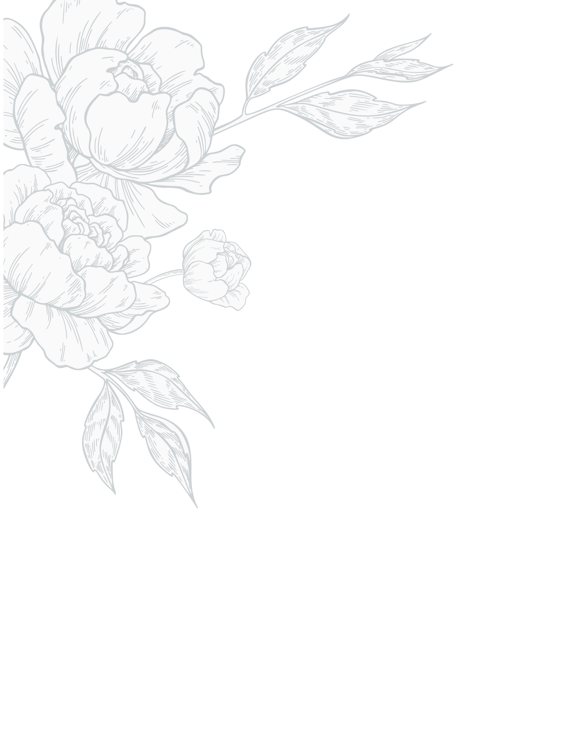
Dinner Menu  $95 Per Person  $145 Including Cocktail Pairings  Plus, tax & gratuity | Sheraton Dallas Hotel  February 14, 2023  Romantic Valentine’s Day Menu  Appetizer  Apple & Pecan Baked Brie (for two)  Black Pepper Crostini  Paired: Bitter Hearts  Salad  Pomegranate Salad  Baby Lettuces, Strawberries, Prosciutto, Shaved Parmesan  Champagne Vinaigrette  Paired: Scarlet Kiss  Main  Salmon Steak with Lobster Risotto  Lemony Asparagus and Fennel  Paired: Hearts on Fire  Or  Bacon-wrapped Filet Mignon & Poached Prawn  Roasted Potatoes and Bourbon Glazed Carrots  Paired: Love Potion  Sweet  Chocolate Covered Strawberry Cheesecake  French Kiss

