Press Release

For Immediate Release

Deborah Brown

214-649-1773

deborah@nigelbrown.com

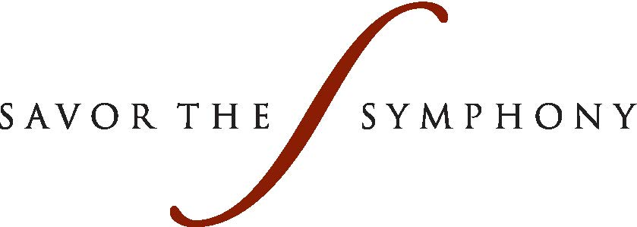

DSOL Savor the Symphony Gala Benefits
Music Education Programs

Evening Dedicated to the Memory of Margaret McDermott

The Dallas Symphony Orchestra League was excited to bring back the very popular Savor the Symphony which began in 2000. The event was held on May 3 at The Ritz-Carlton, bringing together Symphony patrons and business leaders for an evening with a lavish three-course wine-paired dinner, live and silent auction and a private performance featuring the Dallas Symphony Orchestra’s Principal Pops Conductor and Grammy Award Winner, Jeff Tyzik, along with guest performers, Soprano Camille Zamora and dancers from Tango Caliente.
The Honorary Chairs were Diane and Hal Brierley. The Brierleys are longtime supporters of the DSO and the Dallas community. They have been donors and subscribers to the Dallas Symphony Orchestra since 1986 and Diane has been a member of the DSOL since 1992.
Kim Hext was the event chair and Mari Epperson is the DSOL President.
The elegant night began with a cocktail reception featuring a music duo from the Dallas Symphony Young Strings, one of the programs that will benefit from the proceeds of the evening. The guests had the opportunity to bid on individual bottles of wine and other items in the silent auction, preview the live auction packages and to purchase wine through the Wine Pull.
The live auction included Dallas Symphony packages, a beautiful Michele Deco Diamond Bracelet Watch, a 1989 bottle of Petrus red wine and a vacation package to Vail.
When announcements were made from the stage, Kim Hext dedicated the evening to the memory of Margaret McDermott, an underwriter for the event and a longtime symphony and arts patron. News of her passing had been made the morning of the gala.
The event was made possible in part by sponsors including The Ritz-Carlton, The Park Cities News, Jimmy’s Food Store, SusieCakes, and Fossil.
Underwriters included Diane and Hal Brierley, Eugene McDermott Foundation, Kim and Greg Hext, Sharon and Maurice Ballew, Allison and Brett Brodnax, Lisa and Clay Cooley, Angela Fontana, Caroline Rose Hunt, and Penny Reid and Tom Nolan.
Guests in attendance included Kim Notelmy, Michelle Miller Burns, Lisa and Clay Cooley, Lynn and Allan McBee, Barbara and Don Daseke, Amy and Michael Meadows, Cathy and Michael Haynes, and Caroline Rose Hunt and Robert Brackbill.
The proceeds from the evening will benefit the Dallas Symphony Association and its education and community outreach programs. Some of the quality outreach programs the League supports are: DSO on the Go, Community Concerts and Performances, Cecil and Ida Green Youth Concerts, Symphony Yes!, DSO Kids and Young Strings. A Sponsorship of the Red Violin Program provides a financial gift to the Dallas Symphony Orchestra Young Strings through the Innovators of the DSOL. Children are provided with the sponsored instrument and receive lessons and performance opportunities.
The Dallas Symphony Orchestra League is an organization of volunteers who support the Dallas Symphony Association through service, education and fundraising activities.
Since 1946, the DSO League has worked to support the Dallas Symphony Orchestra through service, education and fundraising efforts. Since 1998, the League has contributed more than $20 million in support of the Dallas Symphony Association’s Community Outreach and Education programs, which help bring the wonder of music to thousands of youths and adults in the Dallas Metroplex.
Photos by Chuck Clark

1 Greg Hext and Event Chair Kim Hext with Honorary Chairs Diane and Hal Brierley.
2 Don Epperson and DSOL President Mari Epperson.
3 Allan and Lynn McBee with Lisa and Clay Cooley.
4 Amy and Michael Meadows.
5 Robert Brackbill, Caroline Hunt, Angie and Marshall Brackbill.
6 Michelle Miller Burns and Kim Noltemy.
7 Anna Marie Austin and Tina Harrington.
8 Gayl McMahon and Sheri Bastie.

###

