June 16 2017  Veteran’s appreciation breakfast  At 9am on June 16,2017 the Helping the Helpless Vets Foundation will partner with the Dallas Area Salvation Army to host an appreciation breakfast for the Veterans of the Harry Hines complex of the Salvation Army. We look forward to serving the smiling faces of our military.  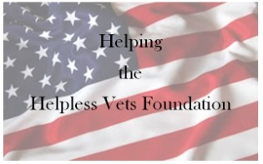 | A Morning of Thanks for Our Veteran’s  ────  Appreciating Our Soldiers Never Gets Old. One of the fundamental goals of our organization is to tirelessly express gratitude to our military.  Helping the helpless vets  2526 Hwy 360 #1207  Grand Prairie, Tx 75050  702 354 9691  Helpingthehelplessvets.blogspot.com  Helpingthehelplessvets.  bl  blogspt  Dates and Times

